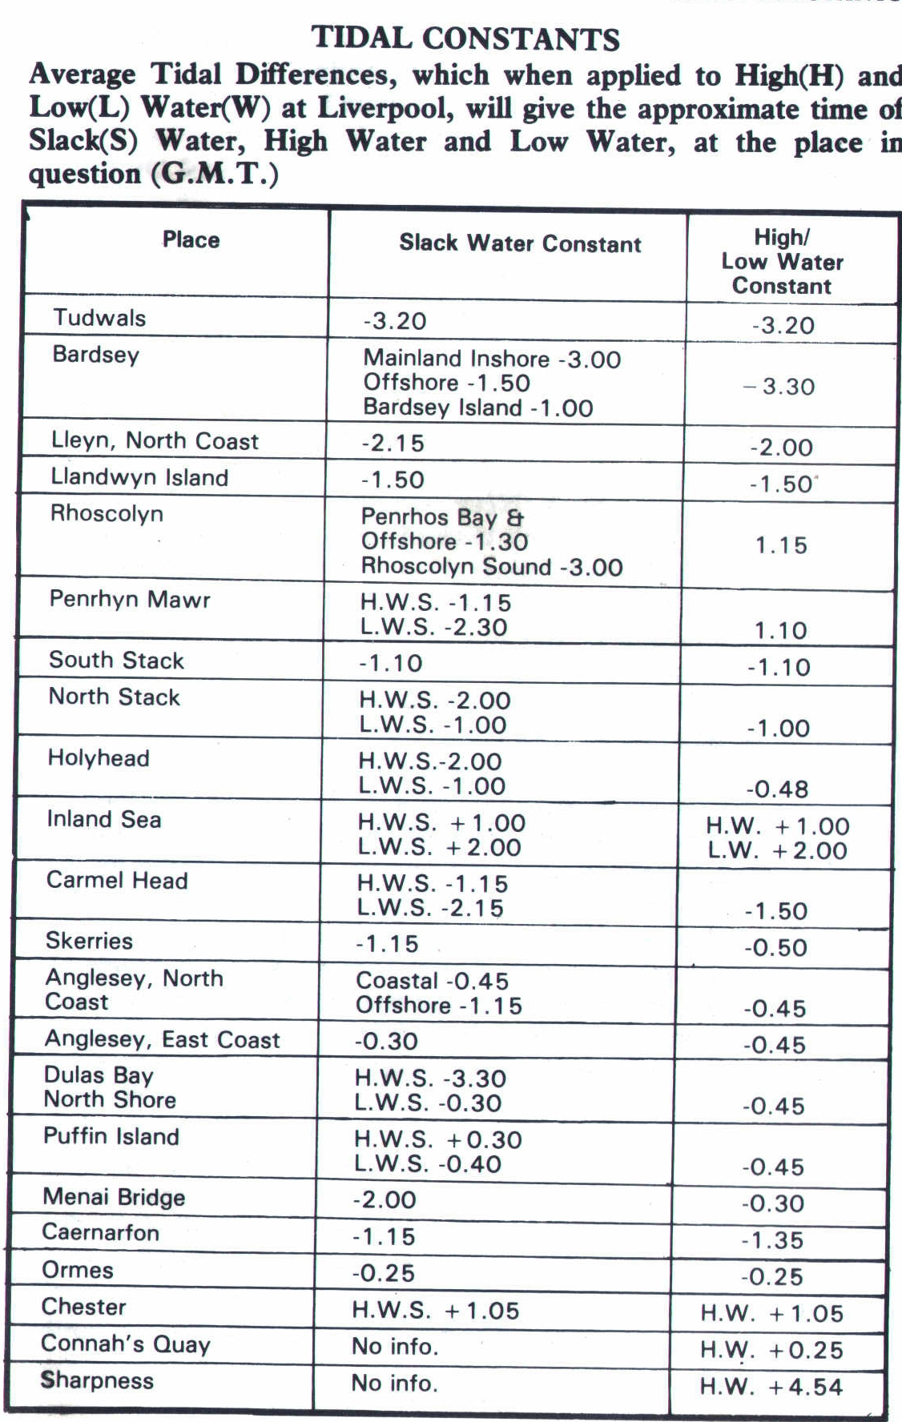

Lights
(F) Fixed continuous
(FL) Flashing
(GP FL) Flashing groups
(V QK FL) Very quick flash
(Occ) Light longer than dark
(GP Occ) Group occulting
(Iso) phase equal light dark
Holyhead coast guard: 01407 762051
Port control (ferry times): 01407 606700
NORTH WALES

