Paraná Delta – Buenos Aires
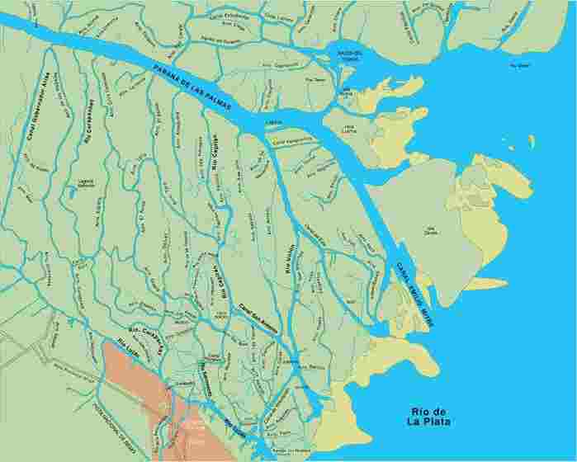
The Paraná Delta is a green area extending from the South West of the Entre Ríos province to the North East of the Buenos Aires province, at the outlet of the Paraná river into the Río de la Plata, 20 km North of Buenos Aires city. At almost 14.000 sq km, the Paraná Delta is a web of islands separated by small rivers and streams advancing continuously into the Río de la Plata. It is originated by sediments coming from the whole Plata basin. The lower Delta shows hundreds of forested islands with ridges at the border and a watery inland.

The vegetation diversity is amazing. Numerous flowers perfume the many channels and rivers: mburucuya, honeysuckle, water hyacinth. Native trees like the ceibo mix with introduced species like the weeping willow, the poplar, the cypress, the eucalyptus and many fruit trees. Fishes are plentiful; the biggest are dorados and atherines.

There is a huge variety of bird species inc. white egret, blue heron, sea gulls, neotropic cormorant, grebe, caracara, kingfisher, woodpecker, grail, coot, limpkin, humming bird, flycatcher, cowbird, scarlet-headed blackbird are some of them. Smaller birds that can be seen and heard are the rush bird, the yellow-winged blackbird and the masked gnatcatcher.

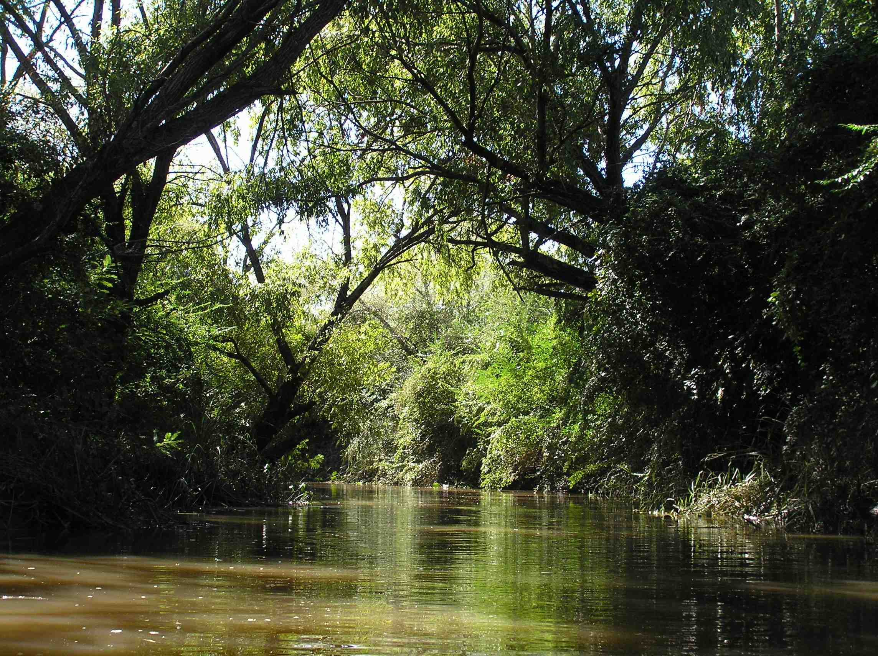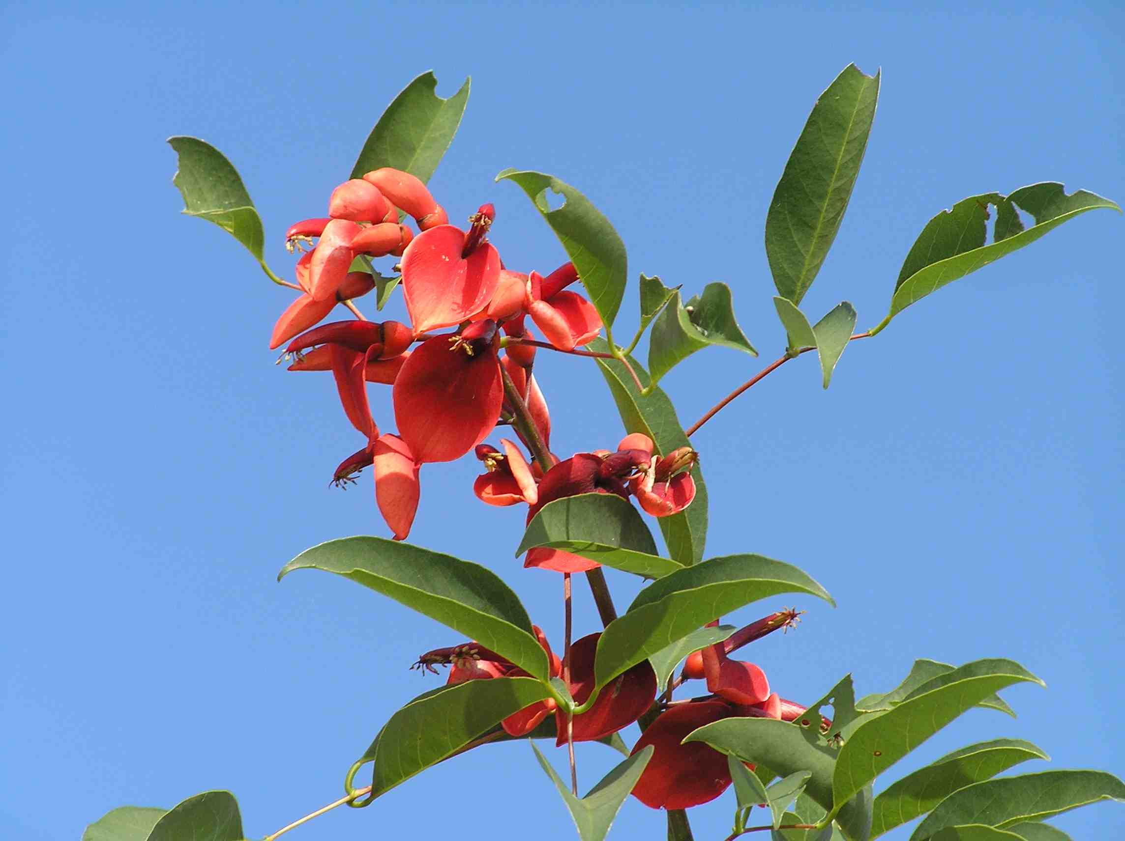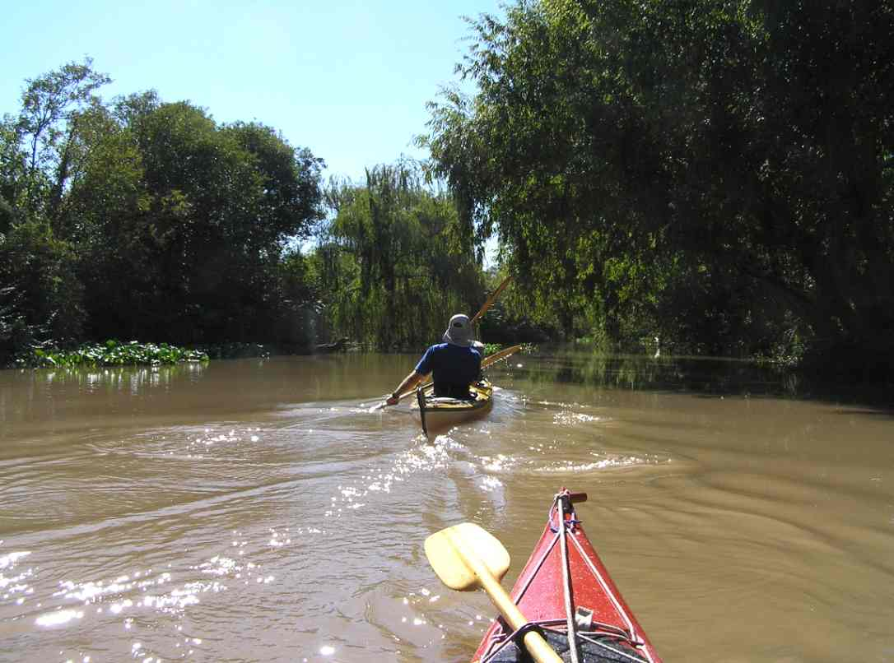

Weather
Weather in Buenos Aires is moderate throughout the year. In summer days are hot and quite humid, with temperatures above 23ºC and as high as 33ºC. In winter average temperature is 12ºC with cold nights. Average monthly precipitation is around 100 mm.

Programs season
All year.

Tierra del Fuego
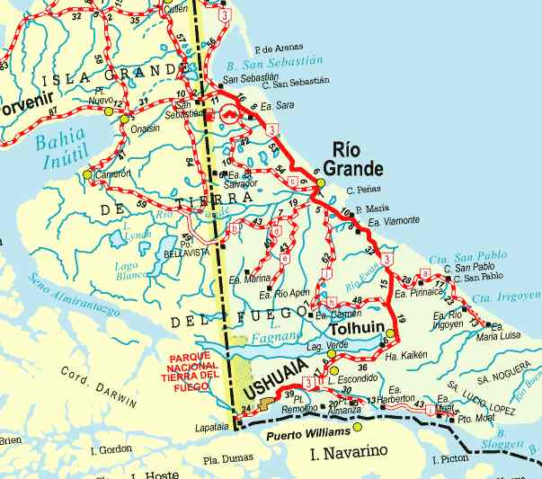
The island of Tierra del Fuego, also referred as El Fin del Mundo or The End of the World was discovered in 1520 by Hernando de Magallanes while he was looking for a path that would connect the Atlantic with the Pacific Ocean.

The city of Ushuaia, the southernmost city in the world and the capital city of the Argentine side or the island, is nestled between the Beagle Channel and the Cordillera Darwin.

Paddling along the Beagle Channel offers breathtaking views of snow covered mountains, a vast natural forest of lengas and ñires as well as thousands of birds such as cormorants, petrels, gulls, upland gooses, flightless steamer ducks and penguins.

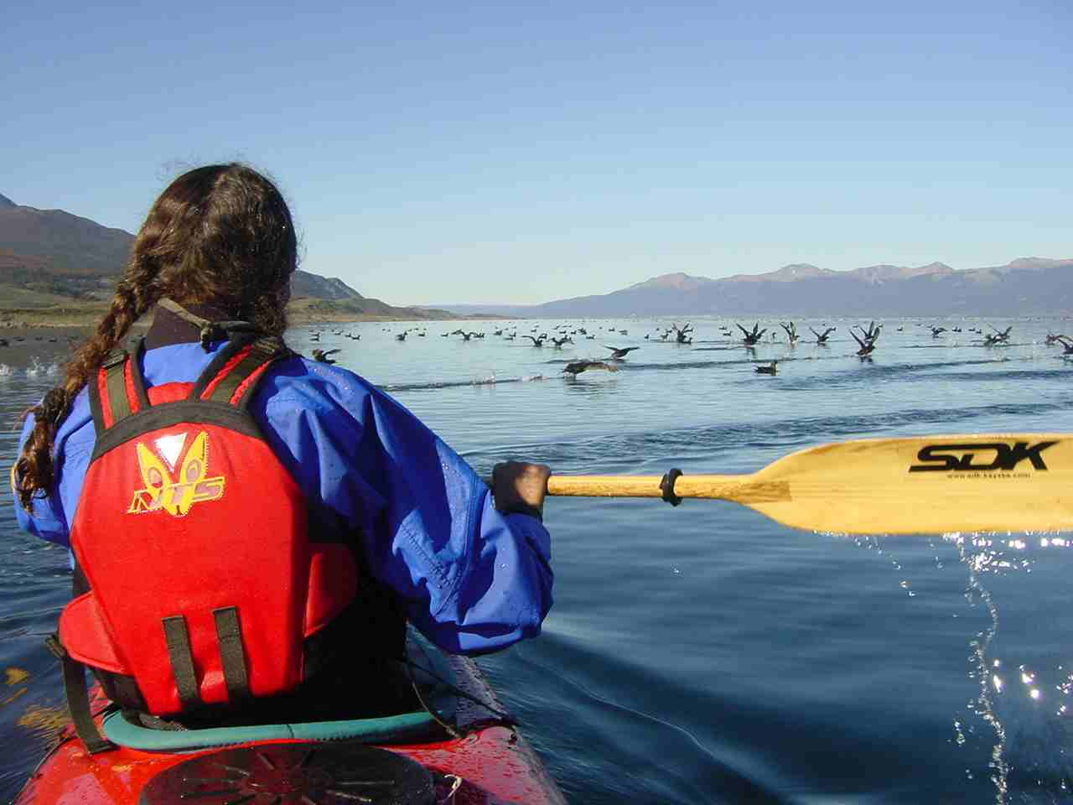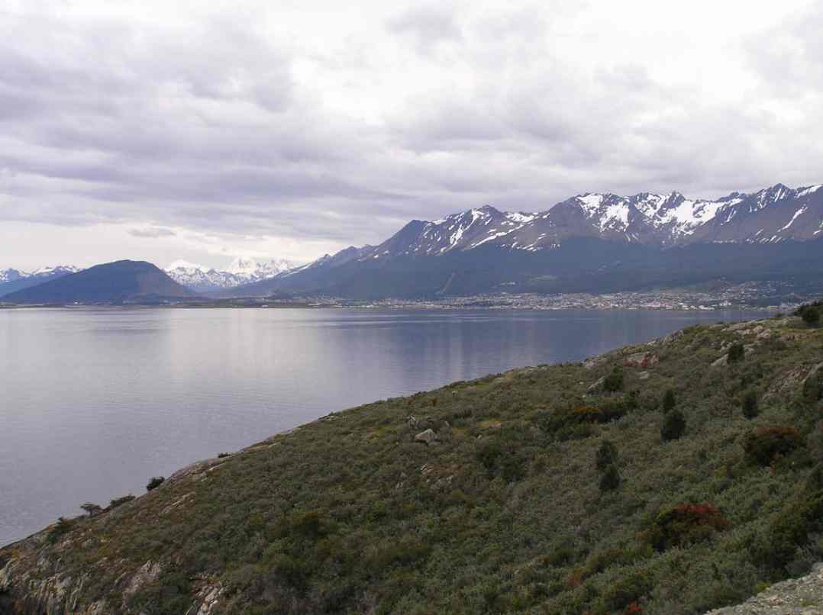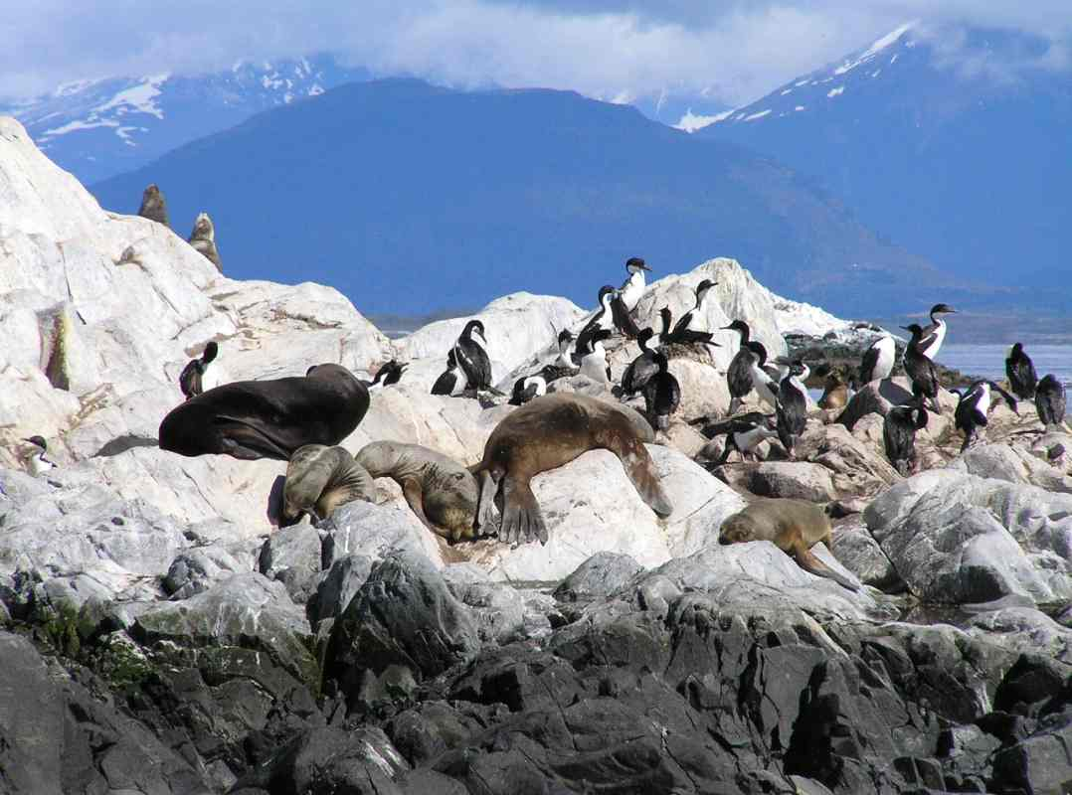

Weather
Traveling in Tierra del Fuego is an unforgettable experience. A harsh weather, with sudden bursts of rain or snow and strong winds makes the area inhospitable and wild, but extremely attractive. Be aware that itineraries in this area are contingent on weather and may change according to the guide's judgment.

Programs season
December to March.

The programs
Tours are divided into Easy and Advanced, half-day, one-day or multi-day programs. Multi-days programs include camping or lodging. Basic instruction is given for beginners prior departure.

 | Half-day  programs | One-day  programs | Multi-day  programs
Overall extent | 4 hours | 7 hours | 2 or 3 days
Kayaking extent | 2 to 3 hours | 5 to 6 hours | 5 to 6 hours per day
Distance paddled | 9 to 10 km | 18 to 20 km | 20 to 30 km

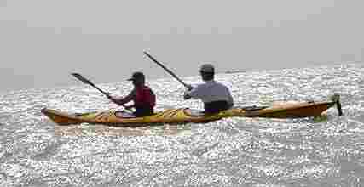
Kayaks and equipment
We provide fully equipped SDK fiberglass double and single sea kayaks with rudder and storage compartments, spray skirts, paddles, buoyancy aids and dry sacks. SDK Kayaks is an argentine company that designs and manufactures fiberglass kayaks since 1982.

We supply full camping gear and tents (double occupancy), communication equipment (VHF), GPS and EPIRB.

You should bring a sleeping bag, a sleeping pad, paddling clothes such as an anorak or dry suit, neoprene boots or gloves and camping clothes. We can provide useful information and a list of appropriate gear and clothing.

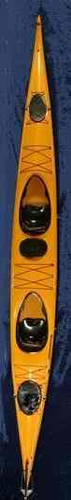
SDK Kaiken double sea kayak – Technical specifications
Standard construction | Fiberglass
Length | 670 cm
Maximum beam | 67 cm
Weight | 37/38 kg
Cockpit size | 86 x 42 cm
Seat pad | Ergonomic
Backrest | Ergonomic, adjustable
Footrest | Aluminum adjustable/ABS
Hatches | Bow, stern and middle
Bow hatch | 32 x 20,5 cm
Stern hatch | 41 x 28,5 cm
Middle hatch | 32 x 21 cm
Rudder system | SDK with control from 1° or 2° cockpit

Designed by Ricardo Kruszewski

For other specifications and models please visit our web site at www.sdk-kayaks.com

Experience and fitness
Prior experience with kayaks is not necessary for Easy programs. A positive attitude towards open-air activities and being in reasonably good physical condition help to enjoy sea kayaking.

We will do our best to make your travel experience satisfactory. However, be aware that as in any outdoor activity, changes in the itinerary may be made due to weather or other unforeseeable conditions.

The guides
Our guides are fully experienced kayakers and environmentalists with knowledge in history, biology and ecology. Multilingual, they have years of experience in leading expeditions in the area.

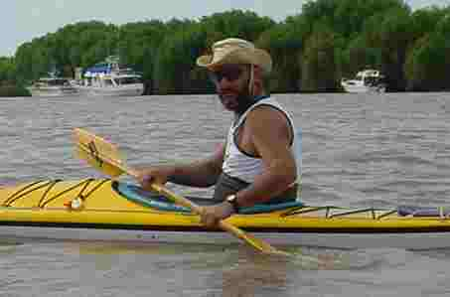
Ricardo Kruszewski. He has more than 20 years experience in the organization of expeditions in Antarctica, Tierra del Fuego and Brazil, as well as kayaking, rafting and mountain bike competitions. Ricardo led the First Expedition to the Cape of Horn and the First & Second Killer Whale Antarctica Project Expeditions in 1991 and 2001. He speaks Spanish, Polish and English.
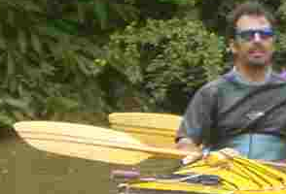
Federico Kessler. With more than 10 years experience in kayaking in the Patagonia area, Brazil and Rio de la Plata, Federico speaks Spanish and French.

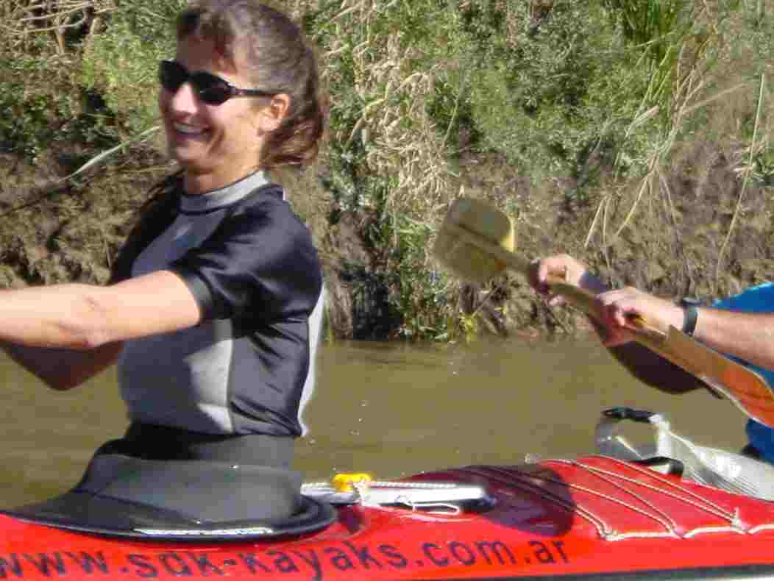
Liliana Nikolic. She discovered the pleasure of kayaking in Alaska many years ago while travelling in America. Liliana has a degree in Tourism and an MBA and speaks Spanish, English, French, Italian and Serbian.

Groups
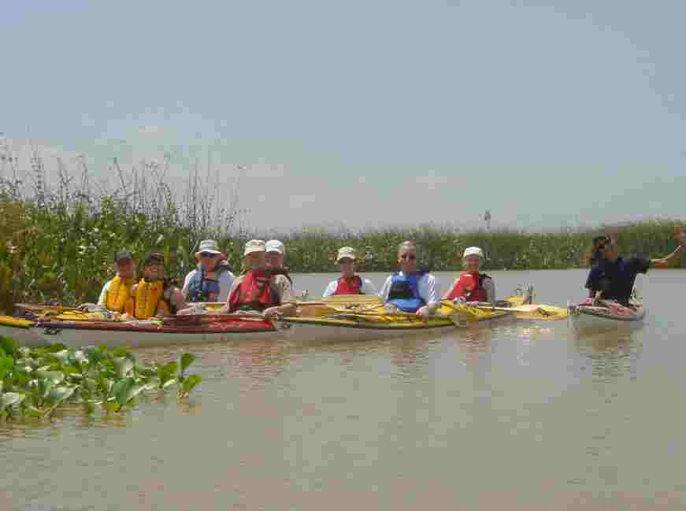
Groups are small, with usually no more than 5 or 6 paddlers. Our goal is to provide an enjoyable sea kayaking experience.

Food & Beverage
We provide all food and beverage. Any special dietary requirements should be made known before departure.

Reservations
For prices please email to info@sdk-kayaks.com. A 50% deposit is required. Balance is due 30 days prior departure date. Cancellation penalties and other restrictions may apply.

Insurance
An international traveler's insurance is highly recommended, covering personal injury, accidents and illness.

Limitations of liability
We will do our best to make your travel experience satisfactory. However, be aware that changes in the itinerary may be made due to weather such as wind, waves or inclement weather, or other unforeseeable conditions. Extra costs due to travel delay or itinerary changes for reasons beyond our control are responsibility of the passenger. At every time we encourage responsible behavior, promoting a safe experience.

Special kayak programs
We organize special single or group programs in Argentina, South of Chile and South of Brazil.

If you are organizing a self-guided or group trip, we can provide logistical support, kayak and equipment rental and boat shuttle.

