Northumberland & Scottish Borders
Sea Kayak Symposium
MAY 26th ~ 29th 2006
If you were at the first one come on back and bring a friend…………..

If you weren’t at the first one come on along and bring a friend…………

If you’re a fledgling sea kayaker and looking for people to paddle with come on along and make some friends…………

If you’re a ”long in the tooth, been there, seen it, done it, paddler”, then come on along and befriend somebody………....
@
NSBSKS
2006
Workshops, coaching, cooking, fishing, demo boats, manufacturers, retailers, slide shows, on the water, off the water, forward paddling, incident management, people who’ve been there, people who haven’t, the pub, music, tall tales, fine ales, sandy beaches, islands, sea birds, seals, castles, cliffs, glasses of wine, the craic.
And what ever you choose to bring with you

to

NSBSKS
2006

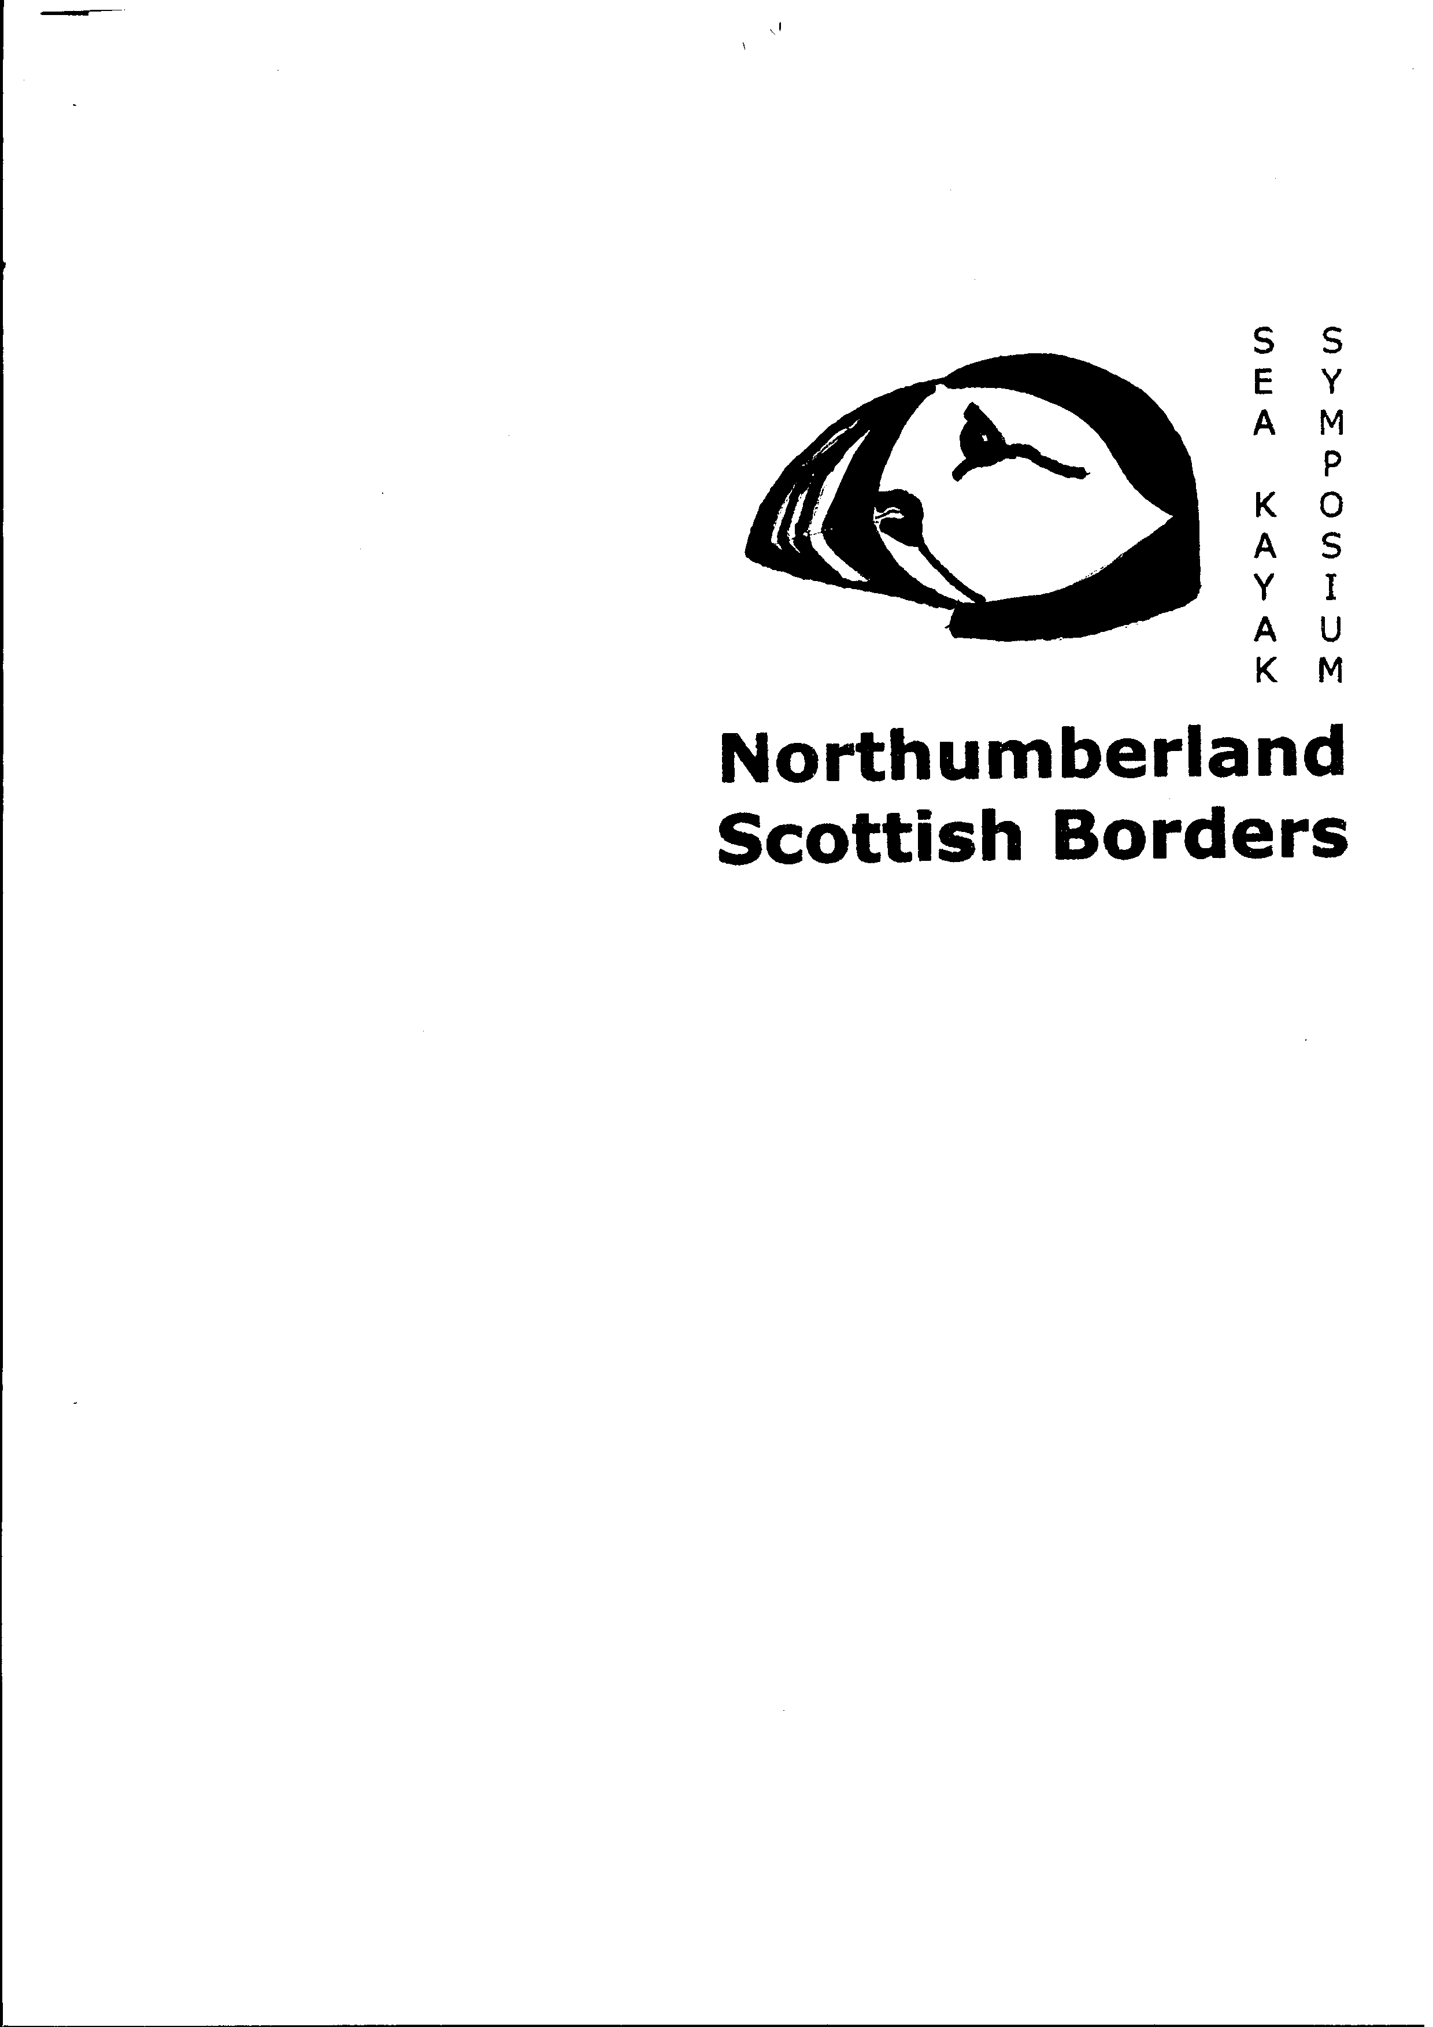

Symposium Venue
COLDINGHAM BAY
BERWICKSHIRE
Symposium Event Only
£75.00
Free Symposium Polo
Shirt to first 25 fully paid up paddlers

CONTACT

nsbsks2006@aol.com

OR

Nsbsks2006, C/o 17 West View, Clara Vale, Ryton, Tyne & Wear, NE40 3SR

If you have difficulty contacting us electronically Remember our postal address is:

Nsbsks2006
c/o
17 West View
Clara Vale
Ryton
Tyne& Wear
NE40 3SR

Or place your cursor over this hyperlink, right click your mouse then click open hyperlink nsbsks2006@aol.com

